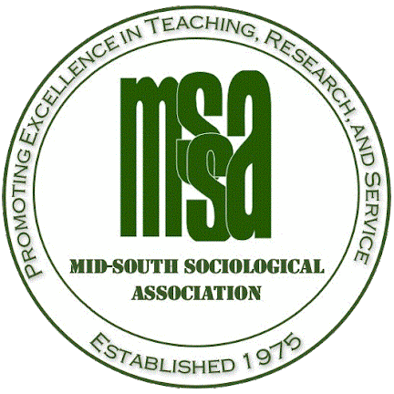

**CALL FOR PAPERS**

Welcome All to a great sociological experience at the MSSA annual conference!

As President-Elect, I am excited to invite you to submit a paper or session for the Annual Meeting of the Mid-South Sociological Association! The conference dates are **October 15-18, 2025,** to be held in **North Augusta, SC.** We’ll be hosting the meeting in-person, with a virtual option for a limited number of sessions.

[***The submission portal is OPEN NOW!***](https://mssa.meetingsavvy.net/login)

This year's theme is:

**Disasters: Understanding the Textures of Loss, Love, and Recovery Amidst Forced Social Change**

Globally, in a world of interlocking networks, the likelihood that most residents will experience a major disaster in their lifetimes is increasing significantly. Whether caused by natural, technological, synergistic, social, cyber, or new means, disasters are becoming more complex, frequent, stronger, longer-lasting, and more devastating in their impacts. As each disaster receives only limited national attention, the extended, slow recovery process forces change and transition at all levels of society, reshaping the pathways forward. Disasters force endings and offer new beginnings. Their destruction spotlights human losses, community ties, deep social change, power dynamics, gender inequalities, wealth and poverty disparities, as well as themes of security, insecurity, and civil rights across varied geographies and cyberspaces. For this conference, we encourage you to submit papers around the theme of disaster with a focus on the humanistic impacts, to understand the texture of loss, the emergence of care and love amidst such devastation, and the process of recovery in a myriad of social and cultural contexts. We are also interested in ways disaster concepts and theorization can apply to new social contexts, expanding our understanding of the theories and bridge the gap between disciplines and perspectives.

Not a disaster scholar? That’s great, too–your valuable sociological work in any area of expertise is absolutely welcome. Whether you submit a panel, paper, roundtable, or workshop, ***ALL TOPICS ARE WELCOME!***

**Presidential Sessions include:**

-Internal Disaster Displacement

-Lived Experiences of Displaced Scholars

-Indigenous Frameworks of Disaster Knowledge

-Universities Facing Disaster

**Ready to submit?**

The submission portal is now open! We look forward to your submissions! The deadline is **September 1, 2025**.

Click [HERE](https://mssa.meetingsavvy.net/login) to submit your abstract, or copy and paste the following link into your browser: https://mssa.meetingsavvy.net/login. Do indicate whether you plan to present in-person or virtually, and your presenting authors. For help with submissions, please refer to the [step-by-step submission instructions](http://www.midsouthsoc.org/conference/registration-membership-and-reservations/).

**Summary of Session Types:**

**Panel Session**: A discussion focused on a particular topic guided by a group of panelists.

**Paper Session**: 3-5 individuals present their research, followed by a Q&A session.

**Poster Session**: Individual presenters display a poster version of their research and provide a brief description to viewers.

**Roundtable**: Conducted at a round table, intended to bring together individuals interested in a particular topic to discuss ideas, ongoing research, or ask questions.

**Workshop**: Directed sessions with the goal of participatory learning.

**Any questions?**

Have inquiries about the conference? Do send your questions to Jess Pardee, president-elect, at [mssaprogramchair@midsouthsoc.org](mailto:mssaprogramchair@midsouthsoc.org) or check out our website at [www.midsouthsoc.org](http://www.midsouthsoc.org)! I’m so very excited to see you all again, or meet you for the first time–MSSA is happy to support your sociological dreams!

I can’t wait to see you all in North Augusta!

Jess

Jess Pardee, Ph.D.

MSSA Program Chair and President-Elect

Looking to get involved? Contact us!

[www.midsouthsoc.org](http://www.midsouthsoc.org)

@MidSouth_Soc

facebook.com/MidSouthSoc

@mssasociology.bsky.social